# Chapter 10: Introducing CSS

-CSS allows you to create rules that control the way that each individual box (and the content of that box) is presented.

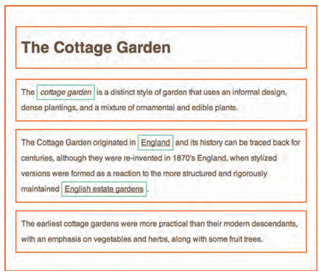

+Block level elements are red borders, inline elements have green borders

+<body> element creates 1st box, then <h1>, <h2>, <p>, <i> and <a> each create their own boxes

-Using CSS, you could add a border around boxes, specify its width and height, or add a background color. You could also control text inside a box (color, size, typeface)

-CSS associates style rules with HTML elements

+CSS rule contains 2 parts: selector + declaration

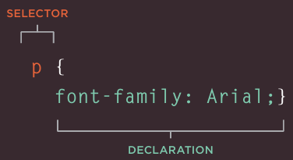

Selectors indicate which element the rule applies to

Declarations indicate how elements referred to in the selector should be styled. Declarations are split into 2 parts: a property and a value.

-CSS properties affect how elements are displayed

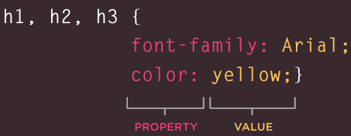

-Using external CSS: <link> tell the browser where to find CSS file used to style the page

+href: specify the path to CSS file

+type: specify the type of document: text/css

+rel: specify the relationship between HTML page and file it is linked to: stylesheet

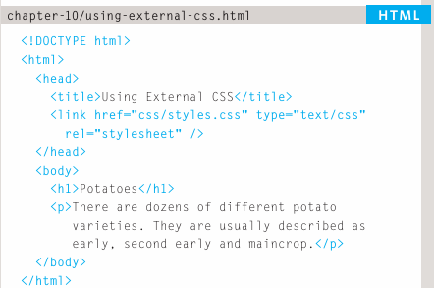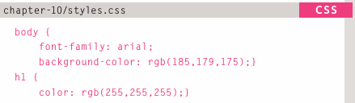  
-Using internal CSS: <style>

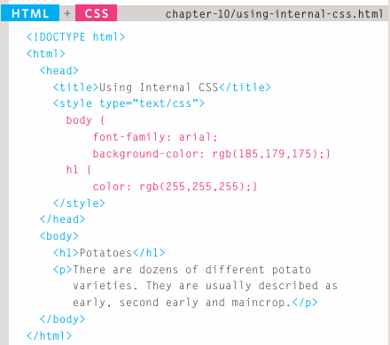

-CSS selectors:

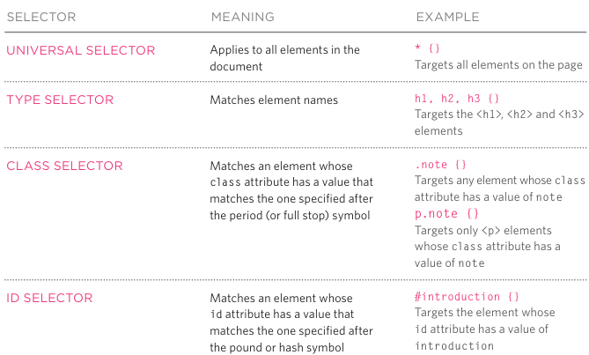

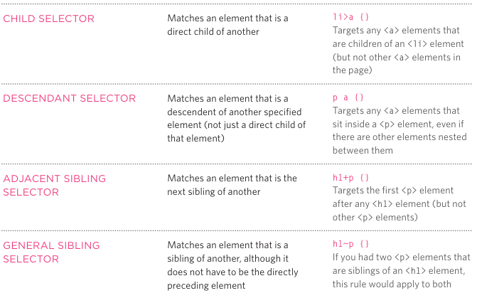

-How CSS rules cascade:

+If there are 2 or more rules that apply to the same element

+last rule: If 2 selectors are identical, the latter of 2 will take precedence

+Specify: If one selector is more specific than others, the more specific rule will take precedence.

+Important: Add !important after any property value to indicate that it should be considered more important than other rules that apply to the same element.

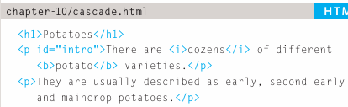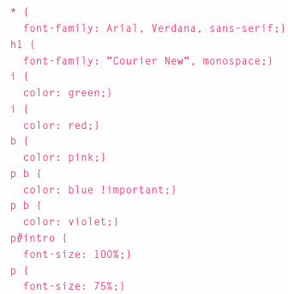

-Inheritance: The value of property can be inherited by child element.

+You can force properties to inherit values from their parent elements by using **inherit**

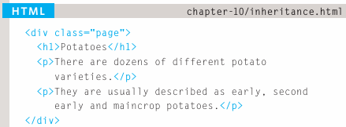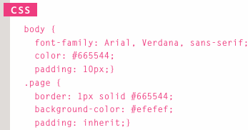

-Why use external style sheets:

+When building a website there are several advantages to placing your CSS rules in a separate style sheet.

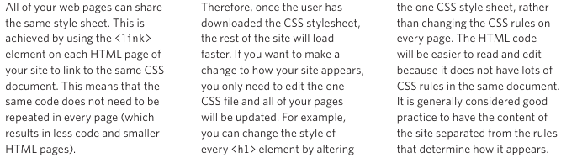

+Sometimes you might consider placing CSS rules in the same page as your HTML code.

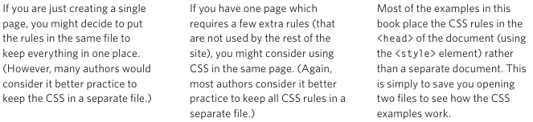

-Different versions of CSS & browsers quirks

+CSS1 was released in 1996, CSS2 in 1998. CSS3 in 2017. CSS4 in 2018. CSS 5 in 2025

+Some online tools to show what a page look like in multiple browsers:

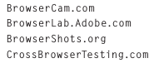

+When CSS property doesn’t display as expected, it generally referred to as a browser quirk or CSS bug

-Summary

+CSS treats each HTML elements as if it appears inside its own box and uses rules to indicate how that element should look.

+Rules are made up of selectors (specify the elements the rule applies to) and declarations (indicate what these elements should look like).

+Different types of selectors allow to target your rules at different elements.

+Declarations are made up of 2 parts: the properties of element that you want to change, and the values of those properties.

+CSS rules usually appear in a separate document, although they may appear within HTML page.

# Chapter 11: Color

-Foreground color: color property allows to specify the color of text inside element.

+RGB values: rgb(100,100,90)

+Hex codes: #ee3e80

+Color names: These are 147 predefined color names

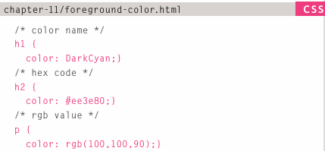

-Background color: background-color property sets the color of the background for the box.

+If you don’t specify a background color, then the background is transparent

+By default, most browser windows have a white background.

-Understanding color: Every color on computer screen is created by mixing amounts of red, green and blue. To find the color you want, use color picker

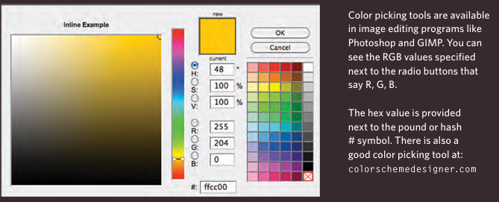

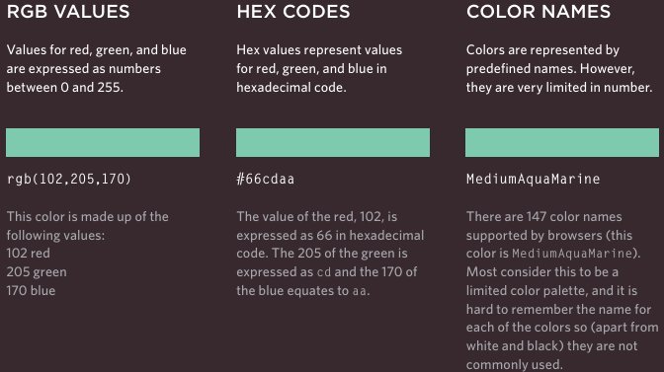

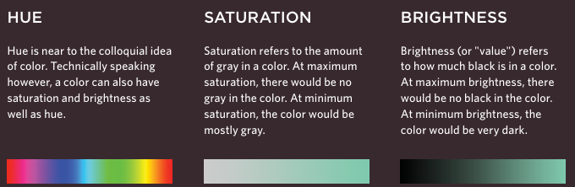

-Contrast:

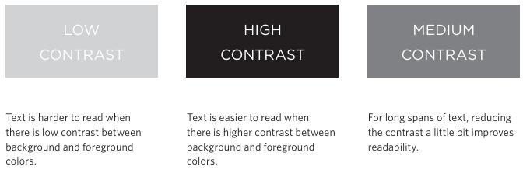

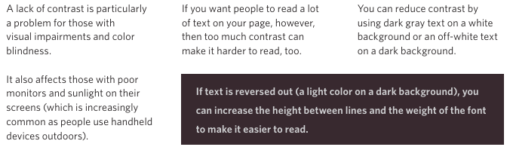

-CSS3: Opacity:

+opacity: specify the opacity of an element and any of its child element. The value is 0,0->1.0

+rgba: specify a color, add 4th value to opacity.

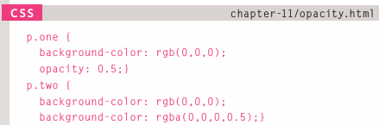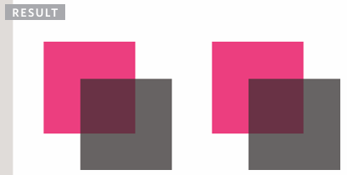

-CSS3: HSL Colors

+CSS3 introduces an new and intuitive way to specify colors using hue, saturation and lightness values.

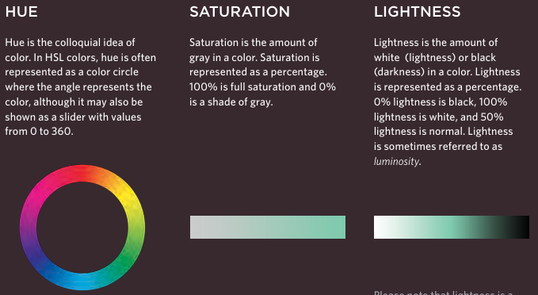

-CSS3: HSL & HSLA

+hsl property

hue: expressed an angle (0-360)

saturation: a percentage

lightness: percentage (0%-100%)

+hsla: hue, saturation, lightness, transparency (0-1.0)

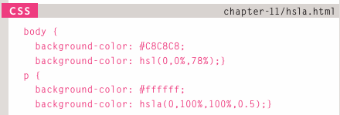

+a stands for alpha.

-Summary:

+Color not only brings site to life, but also helps convey the mood and evokes reactions.

+There are 3 ways to specify colors in CSS: RGB values, hex codes and color names.

+Color picker can help you find the color you want.

+It’s important to ensure that there is enough contrast between any text and the background color (otherwise people will not be able to read your content).

+CSS3 has introduced an extra value for RGB colors to indicate opacity. It’s known as RGBA.

+CSS3 also allows you to specify colors as HSL values, with an optional opacity value. It’s known as HSLA.

# Chapter 12: Text

-Typeface terminology:

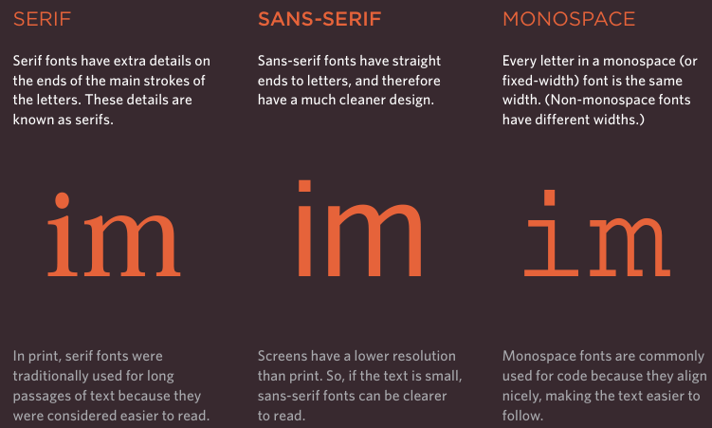

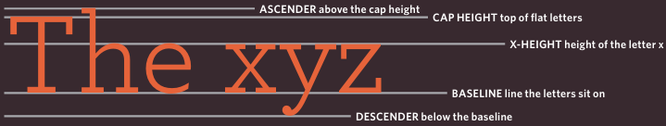

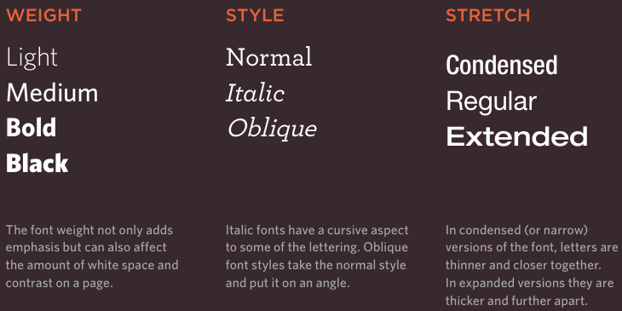

-Choosing a typeface for website:

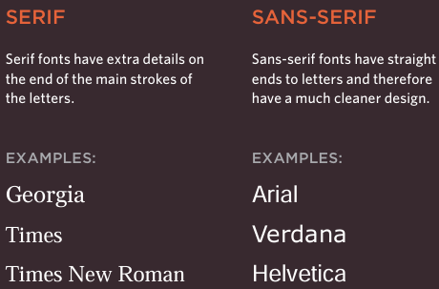

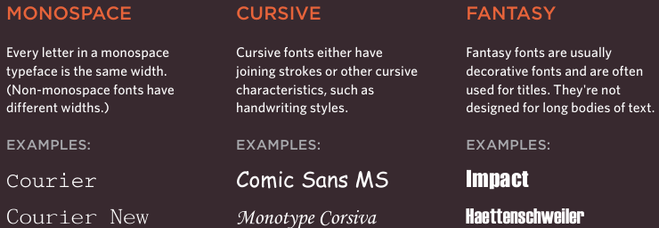

-Techniques that offer a wider choice of typefaces: There are several ways to use fonts other than those listed above. However, typefaces are subject to copyright, so techniques you can choose from are limited by their respective licenses.

-Specifying typefaces: font-family: specify the typeface that should be used for any text inside elements to which CSS rule applies

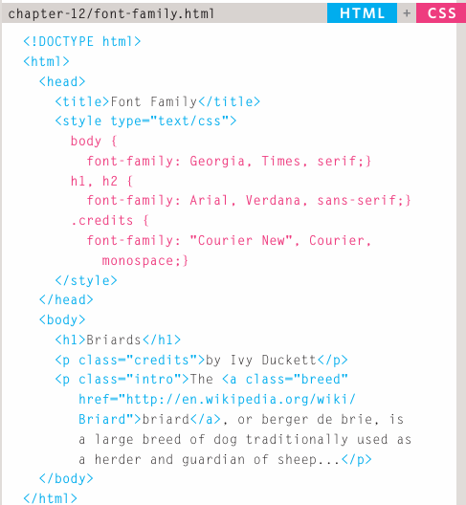

-Size of type: font-size: specify a size for the font

+pixels: px

+percentages: The default of text in browsers is 16px. So a size of 75% is 12px, 200% is 32px

+ems: the width of a letter m

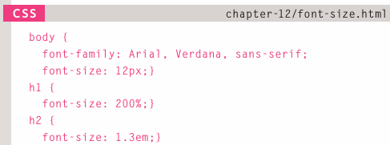

-Units of type size:

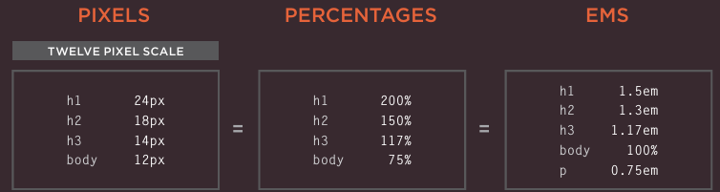

-More font choice: @font-face: use a font even if it isn’t installed on computer by specify a path to a copy of the font

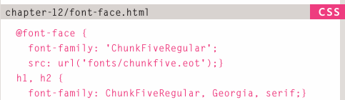

+Open source fonts: 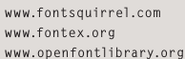

+Commercial fonts: 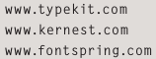

+Open source fonts of Google

-Understanding font formats:

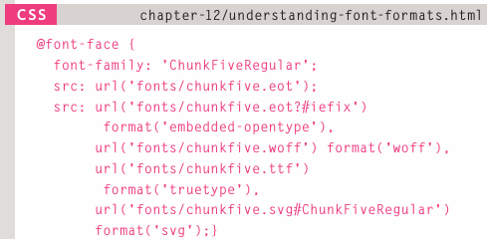

+Different browsers support different formats for fonts. Upload the font FontSquirrel; ERROhttps://www.fontsquirrel.com

-Bold: font-weight: normal + bold

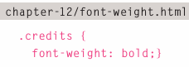

-Italic: font-style: normal + italic + oblique

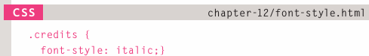

-Uppercase & lowercase: text-transform: uppercase+lowercase+capitalize

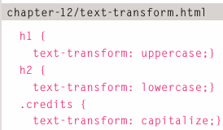

-Underline & strike: text-decoration: none + underline +overline+line-through+blink

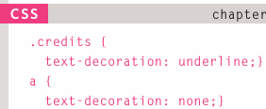

-Leading: line-height

+Leading is the vertical space between lines of text.

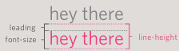

+line-height sets the height of an entire line of text, so the difference between font-size and line-height is leading.

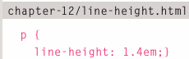

-Letter & word spacing: letter-spacing + word-spacing

+Kerning: space between each letter.

+letter-spacing: control the kerning

+word-spacing: control the gap between words. The default gap between words is set by typeface (often around 0.25em).

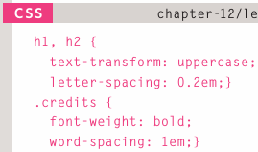

-Alignment: text-align: control the alignment of text

+left+right+center

+justify: indicate that every line in a paragraph, except the last one, should be set to take up the full width of containing box

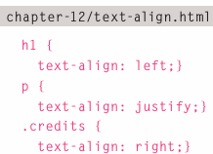

-Vertical alignment: vertical-align:

+Not use with <p>, <div>  
+Use with: <td>, <th>, inline element (<img>, <em>, <strong>)

+The values: baseline, sub, super, top, text-top, middle, bottom, text-bottom

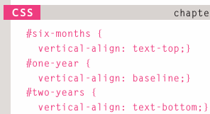

-Indenting text: text-indent: indent the 1st line of text within an element.

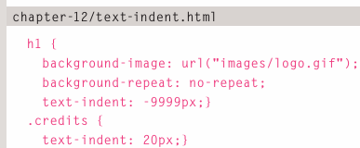

-CSS3: drop shadow: text-shadow

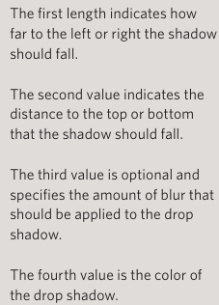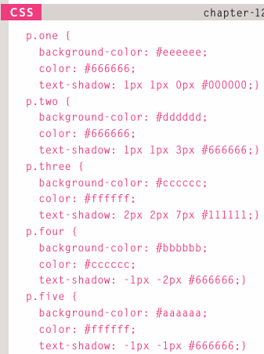

-First letter or line: :first-letter, :first-line

+pseudo-elements: at the end of selector

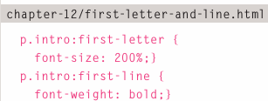

-Styling links: :link, :visited

+:link set styles for links that haven’t been visited

+:visited set styles for links have been clicked on

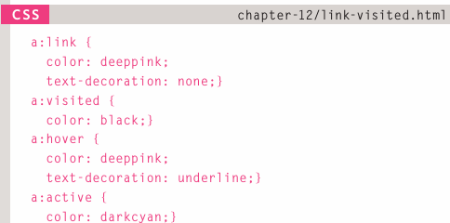

-Responding to users: :hover, :active, :focus

+:hover: apply when user hover an element with a pointing device such as mouse

+:active: element is being activated by user

+:focus: element has focus

+When pseudo-classes are used, they should appear in this order: link, visited, hover, focus, active

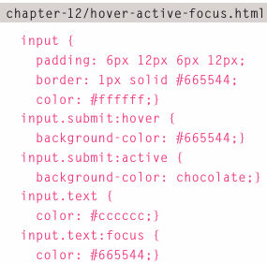

-Attribute selectors: Create rules that apply to elements that have an attribute with specific value

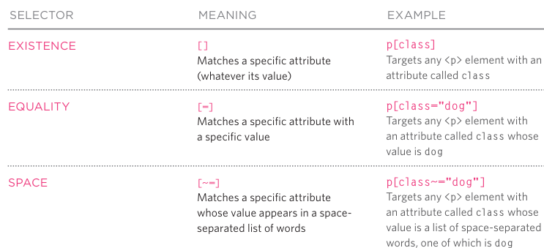

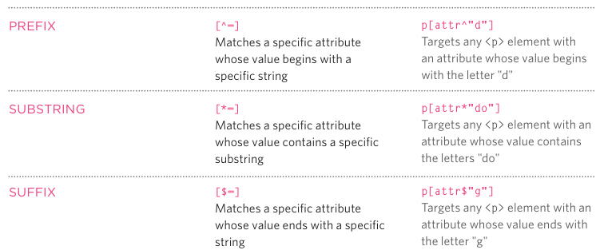

-Summary:

+There are properties to control the choice of font, size, weight, style and spacing.

+There is a limited choice of fonts that you can assume most people will have installed

+If you want to use a wider range of typefaces there are several options, but you need to have the right license to use them.

+You can control the space between lines of text, individual letters, and words. Text can also be aligned to left, right, center or justified. It can also be indented

+You can use pseudo-classes to change the style of an element when a user hovers or clicks on text, or when they have visited a link.

# Chapter 13: Boxes

-Box dimensions: width, height

+By default a box is sized just big enough to hold its contents

+The most popular ways to specify the size of box are pixels, percentages, ems.

+When use percentages, size of box is relative to browser window or containing box.

+When use ems, the size of box based on the size of text within it.

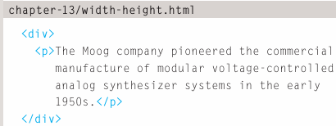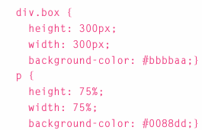

-Limiting width: min-width, max-width

+min-width: specify the smallest size a box can be displayed at when the browser window is narrow.

+max-width: indicate the maximum width a box can stretch to when browser window is wide.

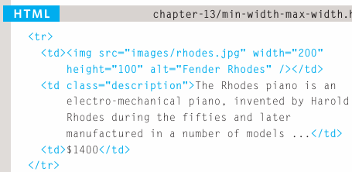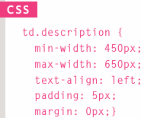

-Limiting height: min-height, max-height

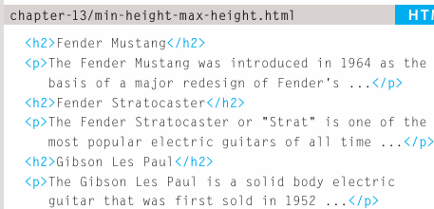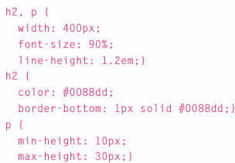

-Overflowing content: overflow: tell the browser what to do if content contained within a box is larger than the box.

+hidden: hides extra content doesn’t fit in the box

+scroll: adds a scrollbar to box.

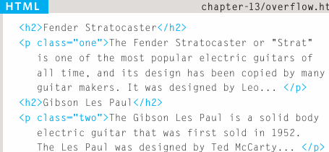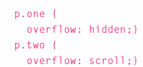

-Border, margin & padding

+Every box has 3 available properties that can be adjusted to control its appearance:

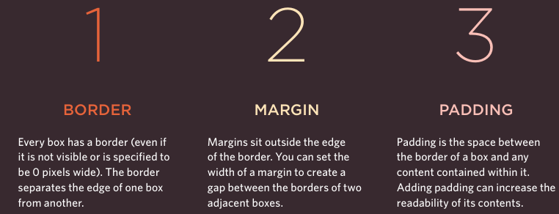

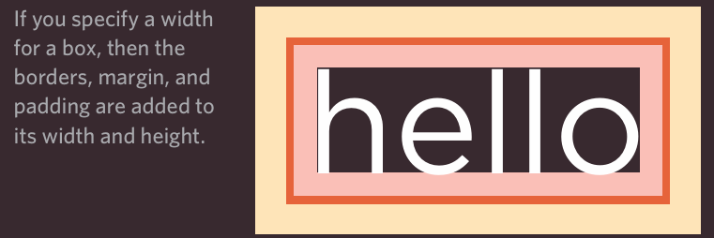

-White space & vertical margin

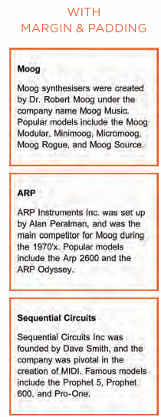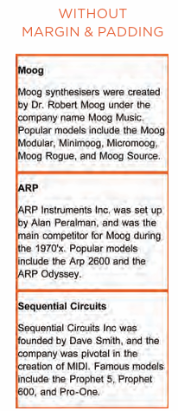

-Border width: border-width

+border-with control the width of border: thin, medium, thick, pixels, border-top-width/border-left-width/border-bottom-width/border-left-width

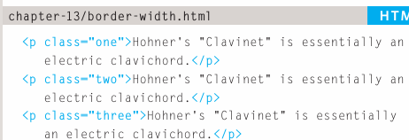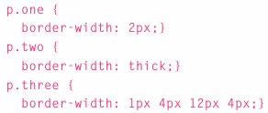

-Border style: border-style

+solid: single solid line, dotted: series of square dots, dashed: series of short lines, double: 2 solid lines, groove: appears to be carved into the page, ridge: appear to stick out from page, inset: appear embedded into page, outset: looks like it’s coming out of screen, hidden/none: no border.

+You can individually change the styles of different border: border-top/left/right/bottom-style

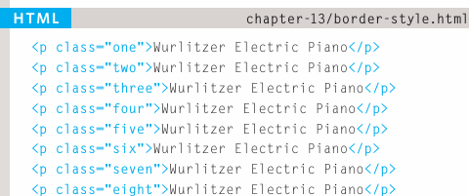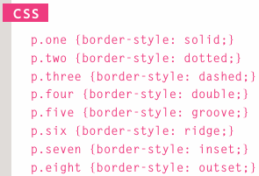

-Border color: border-color

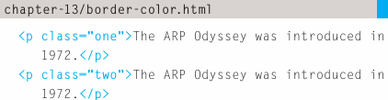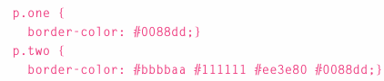

-Shorthand: border: specify the width, style and color of border in one property.

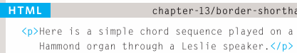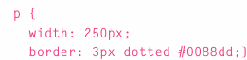

-Padding: padding: specify how much space should appear between the content of an element and its border.

+Most often specified in pixels (percentages/ems)

+If a width is specified for a box, padding is added onto the width of the box.

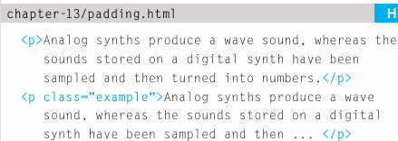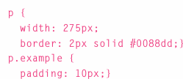

-Margin: margin: control the gap between boxes. It’s commonly given in pixels or percentage/em

+If one box sits on top of another, margins are collapsed: the larger of 2 margins will be used and the smaller will be disregarded

+If the width of box is specified, the margin is added to the width of box.

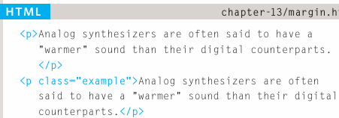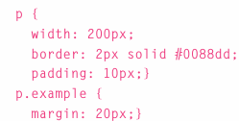

-Centering content

+If you want to center a box on the page (or center it inside the element that it sits in), set left-margin and right-margin to auto

+To center a box on the page, set width for the box

+text-alignment is inherited by child elements. It also needs to specify text-alignment on centered box if don’t want text inside it to be centered

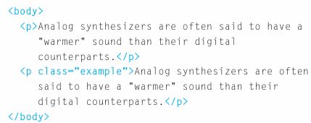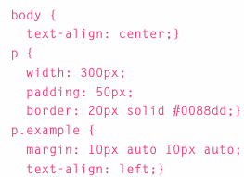

-IE6 box model:

+In Internet Explorer 6 has a quirk it’s includes the padding and margins in width of box.

+Ensure provide DOCTYPE , use HTML5 or HTML4

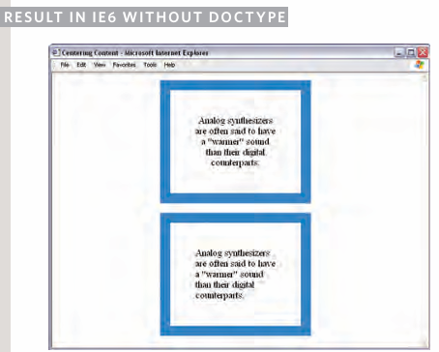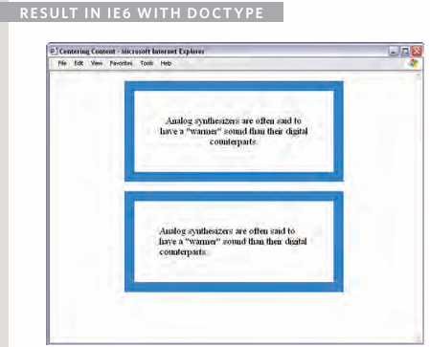

-Change inline/block: display: turn an inline element into block-level element or vice versa, and also hide element.

+inline: causes block-level to inline element

+block: inline element->block level

+inline-block: block-level to flow like inline element, while retaining other features of block level element

+none: hide element from page. Note that inline boxes are not supposed to create block elements

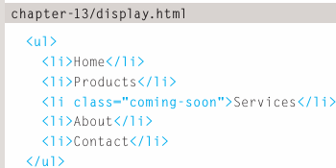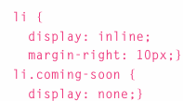

-Hiding boxes: visibility: hide boxes from users but it leaves a space where element would have been

+hidden: hides the element

+visible: shows the element

+If don’t want blank space to apeear: use display:none

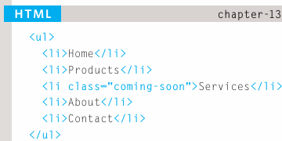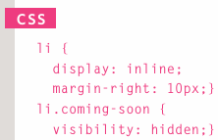

-CSS3: Border images: border-image: apply an image to the border of any box. It takes a background image and slices it into 9 pieces. It requires 3 information:

+URL of image

+Where to slice image

+What to do with the straight edges: stretch, repeat, round

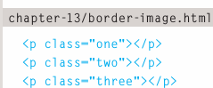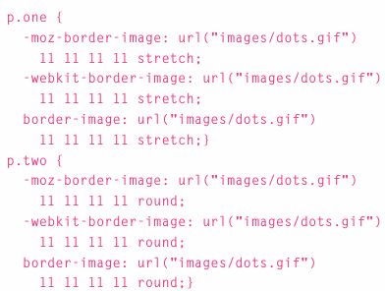

-CSS3: Box shadows: box-shadow: add a drop shadow around a box. It has at least the 1st of 2 value:

+horizontal-offset: negative values position the shadow to left of box

+vertical offset: negative values position the shadow to the top of box

+blur distance: If omitted, shadow is solid line like a border

+spread of shadow: if used, a positive value will cause the shadow to expand in all directions, and a negative value will make it contract

+insert: can be used before these value to create an inner-shadow.

+Chrome, Firefox and Safari were quick to support this property using -moz-box-shadow and –webkit-box-shadow.

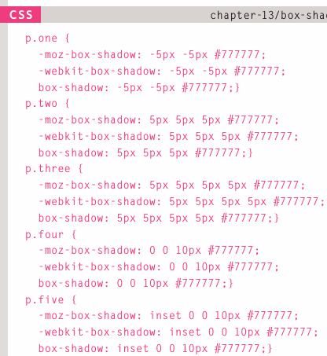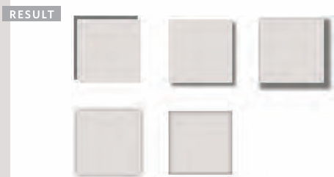

-CSS3: rounded corners: border-radius: indicate the size of the radius in pixels

+-moz-border-radius and -web-kit-border-radius can used in Chrome, Firefox, Safari to support this style

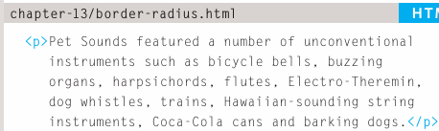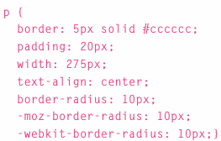

-CSS3: Elliptical shapes: border-radius

+To create more complex shapes, you can specify different distances for horizontal and vertical parts of rounded corners

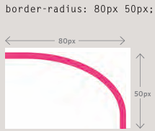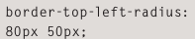

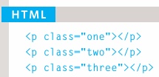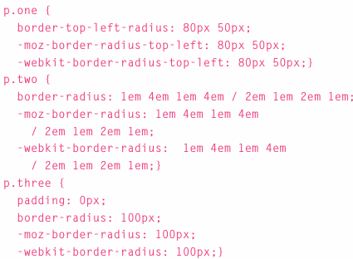

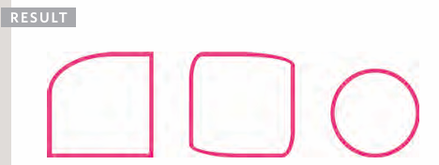

-Summary:

+CSS treats each HTML elements as if it has its box

+You can use CSS to control the dimensions of box

+You can also control the borders, margin and padding for each box with CSS.

+It’s possible to hide elements using the display and visibility properties

+Block-level boxes can be made into inline boxes, and inline boxes made into block-level boxes.

+Legibility can be improved by controlling the width of boxes containing text and the leading.

+CSS3 has introduced the ability to create image borders and rounded bordres.

# Chapter 14: Lists, Tables & Forms

-Bullet point styles: list-style-type: control the shape or style of a bullet point (marker)

+It can be used on rules to <ol> <ul> <li>

+Unordered lists: 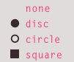

+Ordered lists:

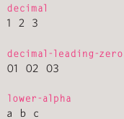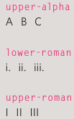

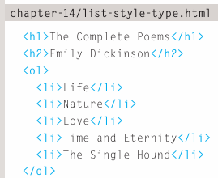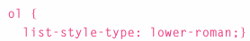

-Images for bullets: list-style-image

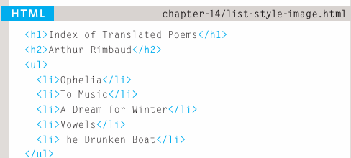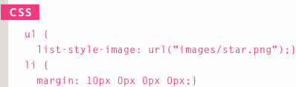

-Positioning the marker: list-style-position: indicate whether the marker should appear inside or outside of the box containing the main point:

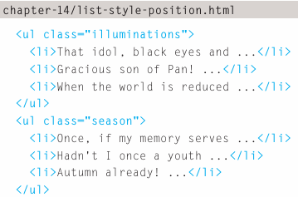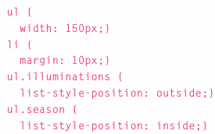

-List shorthand: list-style

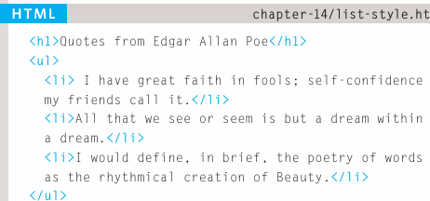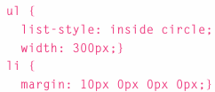

-Table properties

+width: set the width of a table

+padding: set the space between border of each table cell and its content

+text-transform: convert the content of table headers to uppercase

+letter-spacing, font-size: add styling to content of table headers

+border-top, border-bottom: set borders above and below table headers

+text-align: align the writing to the left of some table cells and to the right of others

+background-color: change the background color of alternating table rows

+:hover: highlight a table row when mouse go over it.

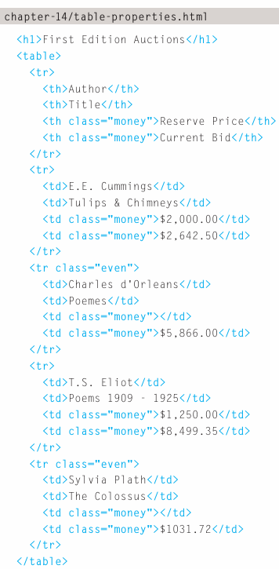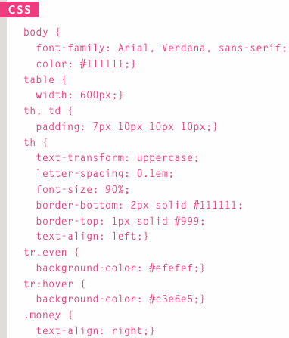

-Border on empty cells: empty-cells: specify whether or not their borders should be shown

+show: shows the borders of empty cells

+hide: hide the borders of empty cells

+inherit: if you have one table nested inside another, this value instructs table cells to obey the rules of containing table.

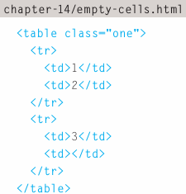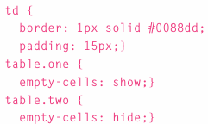

-Gaps between cells: border-spacing, border-collapse

+border-spacing: control the distance between adjacent cells. By default, browsers often leave a small gap between each table cell. The value is in pixels. You can specify 2 values for horizontal and vertical spacing.

+border-collapse: When a border has been used on table cells, where 2 cells meet, the width of lines would be twice that of outside edges. Border-collapse collapse adjacent borders to prevent this

collapse: borders are collapsed into a single border where possible (border-spacing and empty-cells will be ignored)

separate: borders are detached from each other (border-spacing + empty-cells will be obeyed)

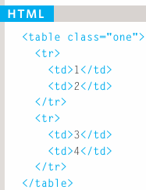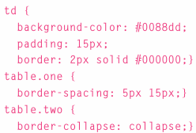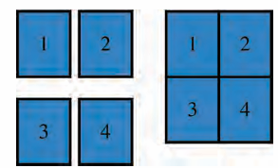

-Styling forms: Styling text inputs and submit buttons is easy, but it’s harder to get select boxes, radio buttons, and checkboxes.

-Styling text inputs:

+font-size: set the size of text entered by user

+color: set the text color

+background-color: set the background color

+border: add a border around edge of input box

+border-radius: create rounded corners

+:focus: change background class when being used

+:hover: user hovers over

+background-image: add background image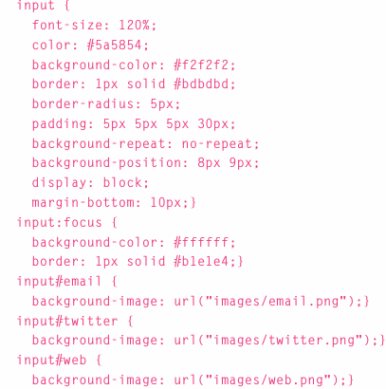

-Styling submit buttons:

+color: change the color of text on button

+text-shadow: 3D look to text

+border-bottom: make bottom border of button

+background-color: change background color

+:hover: user hover it

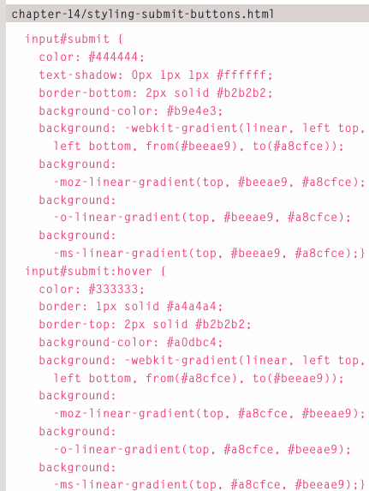

-Styling fieldsets & legends

+fieldset are helpful in determining the edges of form. In a long form they can help group together related information within it.

+lengend: indicate what information is required in fieldshet

+Properties used with 2 elements include: width, color, background-color, border, border-radius, padding.

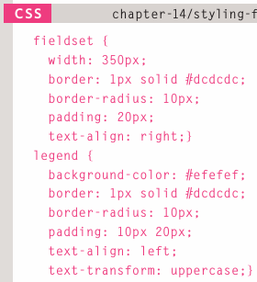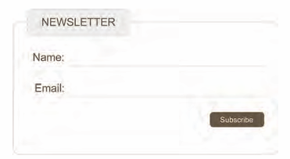

-Aligning form controls: problem

+Labels for form elements are often different lengths, which means that the form controls will not appear in a straight line.

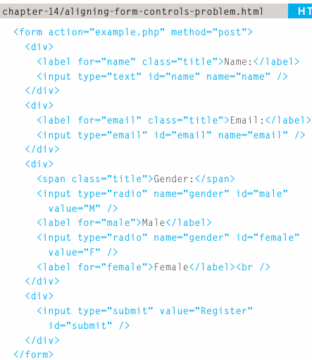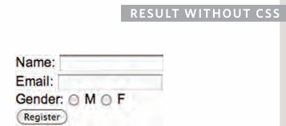

-Aligning form controls: solution

+float: move titles to left of page.

+Set width one elements, the titles will each take up the same width. The form controls next to them will line up.

+text-align: align the title to right, padding make sure there is a gap between text in title boxes and form control.

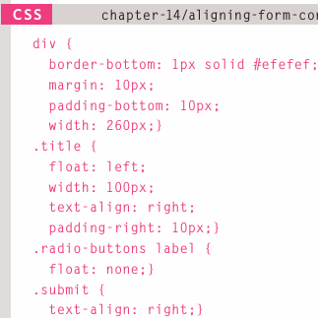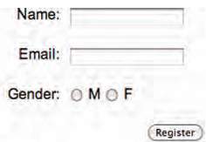

-Cursor styles: cursor: control the type of mouse cursors that should be displayed to users

+Values for this property: auto, crosshair, default, pointer, move, text, wait, help, url(“”)

-Web developer toolbar

-Summary:

+In addition to CSS properties covered in other chapters which work with the contents of all elements, there are several others that are specifically used to control the appearance of lists, tables, and forms.

+List markers can be given different appearances using list-style-type + list-style- image properties

+Table cells can have different borders and spacing in different browsers, but there are properties you can use to control them and make them more consistent

+Forms are easier to use if form controls are vertically aligned using CSS

+Forms benefit from styles that make them feel more interactive

# Chapter 15: Layout

-Key concepts in positioning elements

+Building blocks: CSS treats each HTML elements in its own box. This box will be block-level box or an inline box.

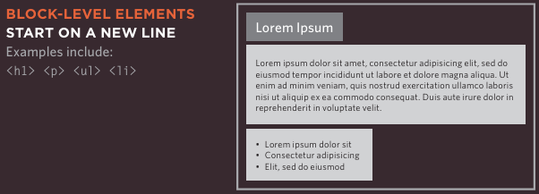

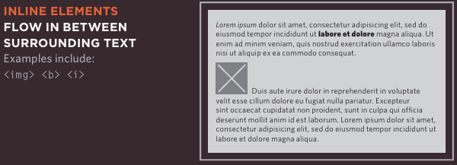

-Containing elements

+If one block-level element sits inside another block-level element then the outer box is the containing or parent element

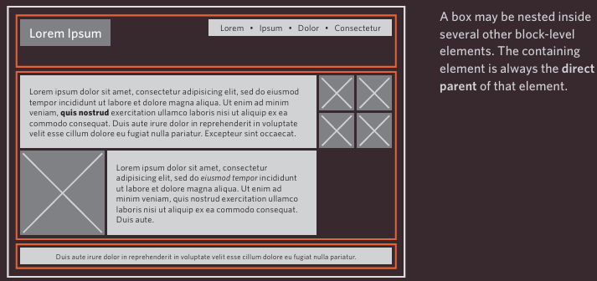

-Controlling the position of elements

+CSS has the following positioning schemes that allow you to control the layout of page: normal flow, relative positioning, and absolute positioning. You specify positioning scheme using position. You can also float element using float.

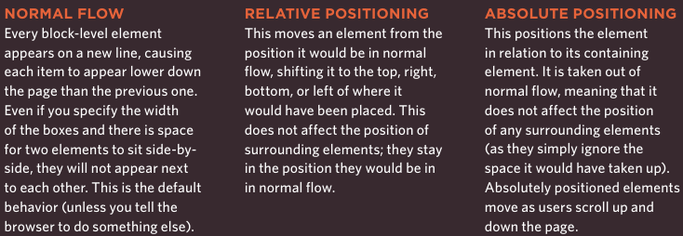

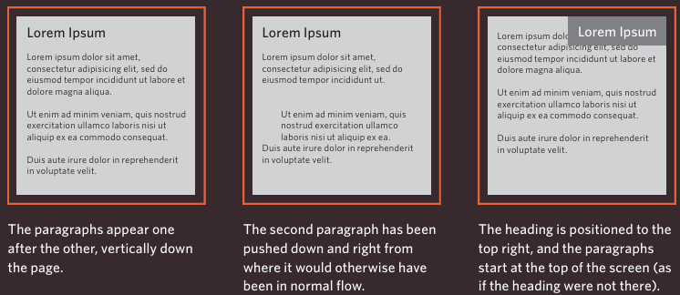

-To indicate where a box should be positioned, also need to use box offset: tell browser how far from top or bottom and left or right it should be placed.

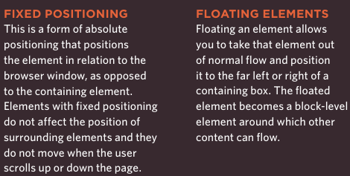

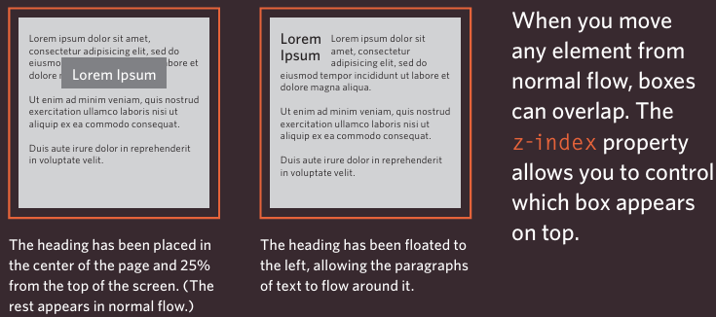

-Normal flow: position:static

+In normal flow, each block-level element sits on top of the next one.

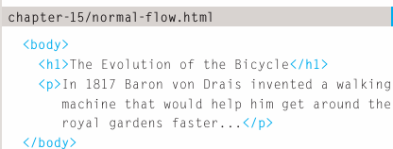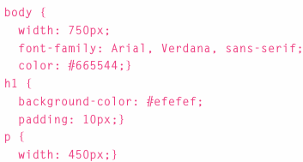

-Relative positioning: position:relative

+position:relative moves an element in relation to where it would have been in normal flow. Example: move it 10 pixels lower than it would have been in normal flow or 20% to the right.

+Use offset properties: top/bottom/left/right to indicate how far to move element from where it would have been in normal flow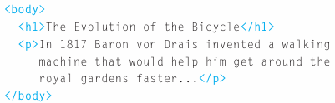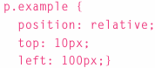

-Absolute positioning: position:absolute

+position:absolute: the box is taken out of normal flow and no longer affects the position of other elements on page.

+Box offset properties (top/bottom/left/right) specify where the element should appear in relation to its containing element.

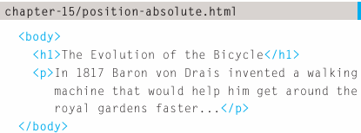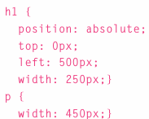

Width applied to <p> to prevent the text from overlapping and becoming unreadable

-Fixed positioning: position:fixed: position the element in relation to browser window. So when a user scrolls down page, it stays in exact same place.

+The box offset properties used to control where the fixed position box appears in relation to browser window.

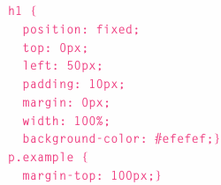

-Overlapping element: z-index

+When you use relative, fixed or absolute positioning, boxes can overlap. If boxes do overlap, elements that appear later in HTML sit on top of those that are earlier in page.

+To control which element sits on top, use z-index. The higher the number the closer that element is to the front. Example: element with z-index=10 will appear over the top of one with z-index=5

+z-index is referred to as tacking context (the blocks have been stacked on top of each other on a z axis)

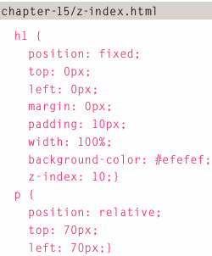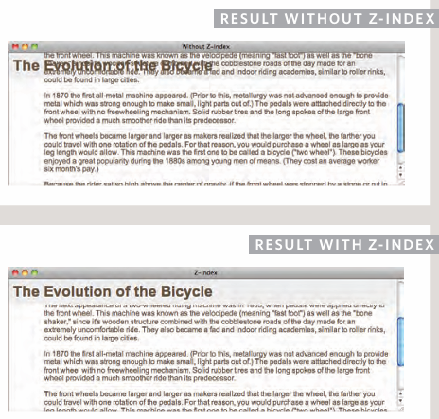

+We use relative for <p> because the paragraphs are relatively positioned, by default they appear over the top of heading as the user scrolls down the page.

-Floating element: float

+float: take element in normal flow and place it as far to the left or right of containing element as possible

+Anything sitting inside containing element will flow around the element that is floated.

+You should also use width to indicate how wide the floated element should be.

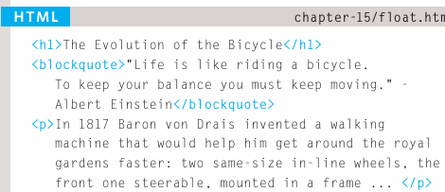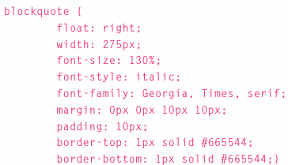

-Using float to place elements side-by-side

+A lot of layouts place boxes next to each other. Float is used to achieve this. When elements are floated, the height of boxes can affect where the following elements sit.

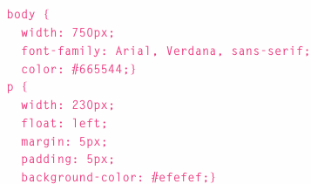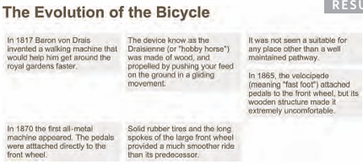

+The 4th paragraph doesn’t go across to left hand edge of page. Because the 4th one has space to start under the 3rd, but it can’t go any further to the left because the 2nd is in the way. -> Set the height of paragraph to be the same height as the tallest paragraph would solve this issue. Or use clear.

-Clearing floats: clear: allows to say that no element (within the same containing element) should touch the left or right hand sides of a box.

+left: the left-hand side of box should not touch any other elements appearing in the same containing element.

+right: the right-hand side of box should not touch any other elements appearing in the same containing element.

+both

+none: elements can touch either side

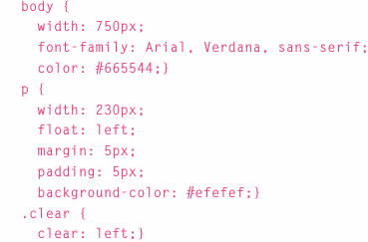 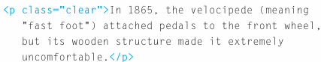

-Parents of floated elements: problem

+If a containing element only contains floated elements, some browsers will treat it as if it is zero pixels tall.

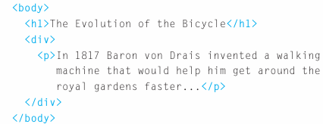 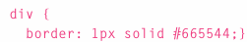

-Parents of floated elements: solution

+overflow:auto

+width:100%

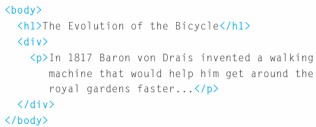 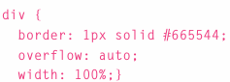

-Creating multi-column layouts with floats

+Many web pages use multiple columns in design. Using a <div> to represent each column. Then use 3 properties:

+width: sets the width of columns

+float: positions the columns next to each other

+margin: creates a gap between the columns

-Screen sizes

+Different visitors to the site will have different sized screens that show different amounts of information, so the design needs to be able to work on a range of different sized screens.

-Screen resolution: the number of dots a screen shows per inch.

-Page sizes: Screen sizes and display resolution vary so much, web designers often try to create pages of around 960-1000 pixels wide.

-Fixed width layouts:

+Fixed width layout designs don’t change size as the user increases or decreases the size of their browser window. Measurements tend to be given in pixels

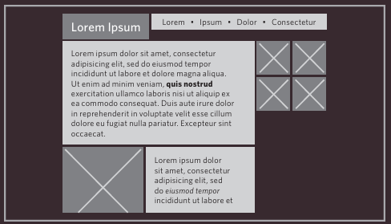

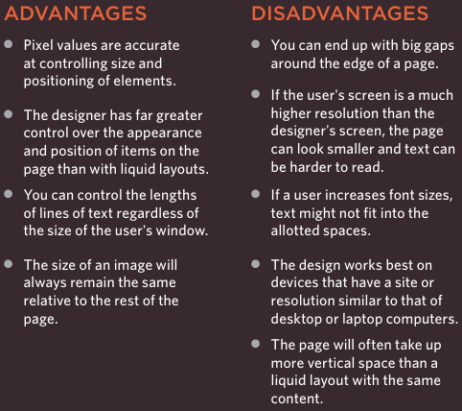

-Liquid layouts

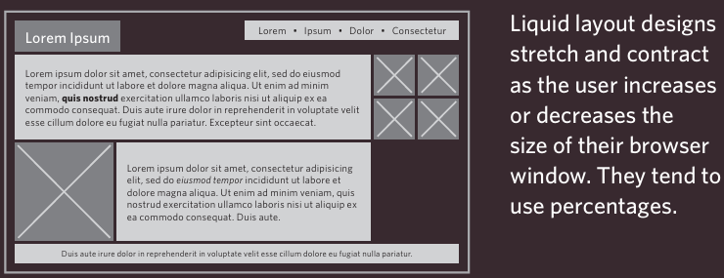

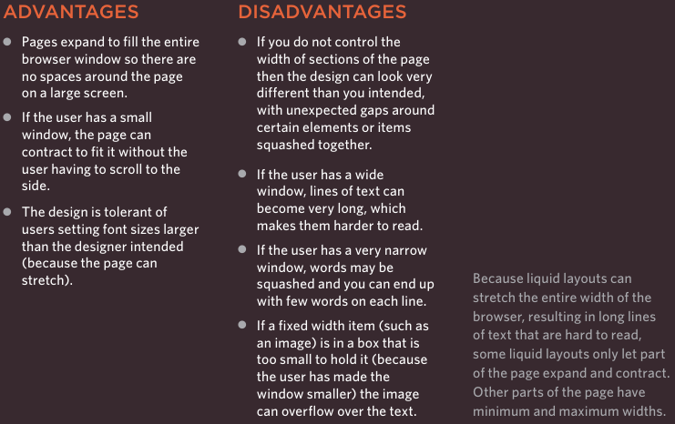

-A fixed width layout:

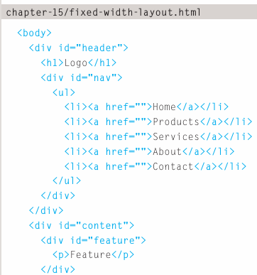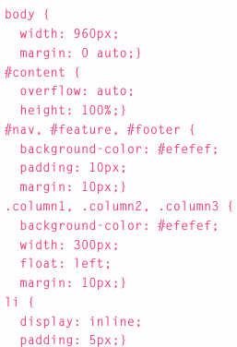

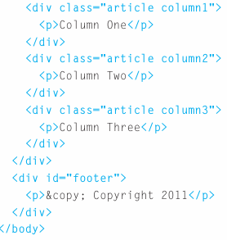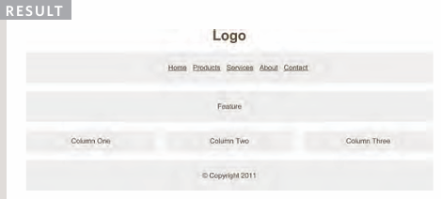

-A liquid layout:

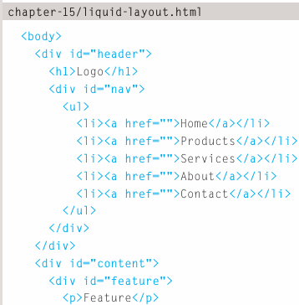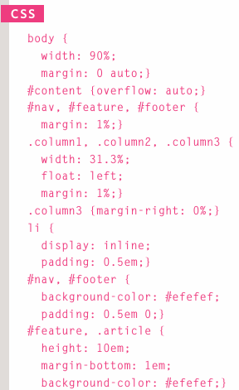

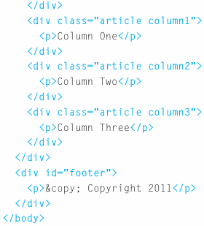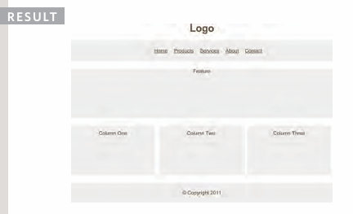

-Layout grids:

+Composition in any visual art (design, painting, photography) is the placement or arrangement of visual elements-how they are organized on page. Many designers use grid structure to help them position items on page, and the same is true for web designers.

+The grid 960 pixel grid widely used by designer

-Example grid:

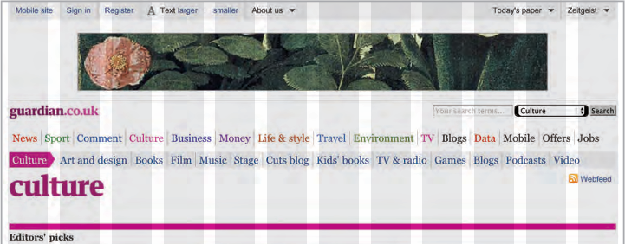

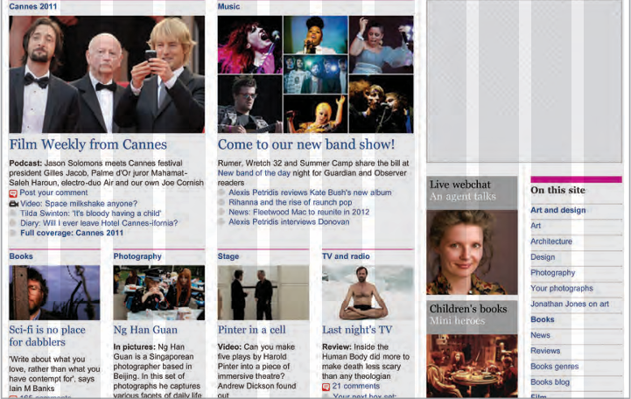

-Possible layouts: 960 pixel wide 12 column grid

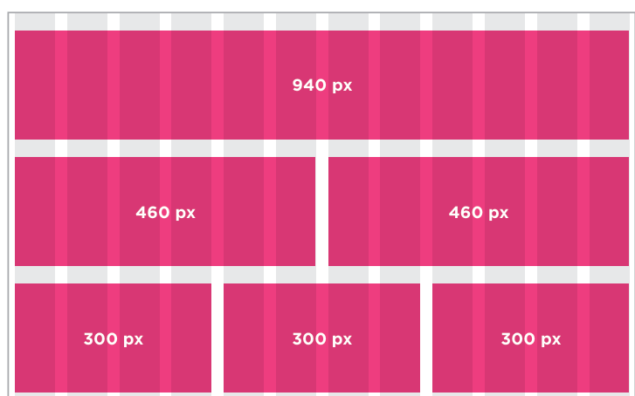

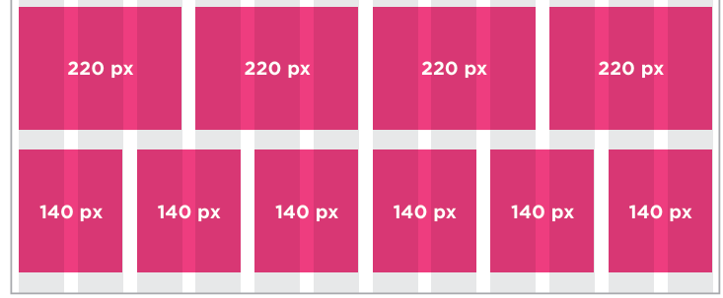

+The page is 960 pixels wide and there are 12 equal sized columns (shown in gray), each of which is 60 pixels wide. Each column has margin 10 pixels.

-CSS frameworks

+CSS frameworks aim to make easier by providing the code for common tasks: creating grids, styling forms, creating printer-friendly versions of pages… You can include CSS framework code in project rather than writing CSS from scratch.

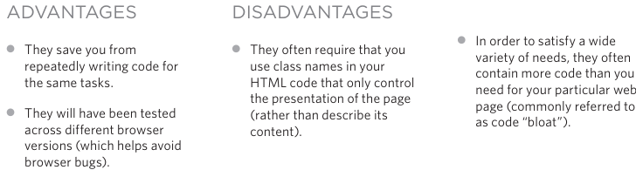

-Introducing the 960.CSS framework: [www.960.gs](http://www.960.gs)

+960.gs provides a style sheet that you can include in HTML pages.

+To create 12 column grid, use class container_12

+There are different classes for blocks that take up 1,2,3,4 and up to 12 columns of grid: grid_3, grid_4. These columns all float to left, margin=10

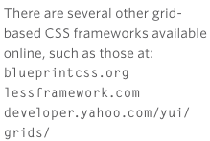

-Multiple style sheets: @import

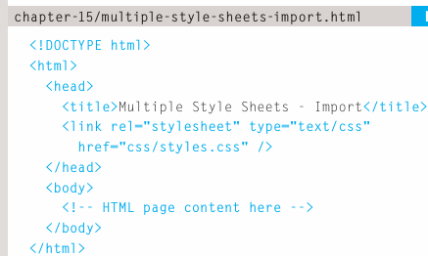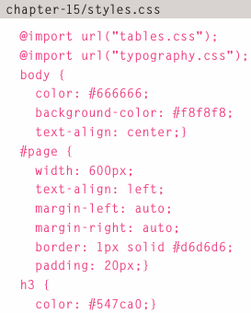

-Multiple style sheets: link

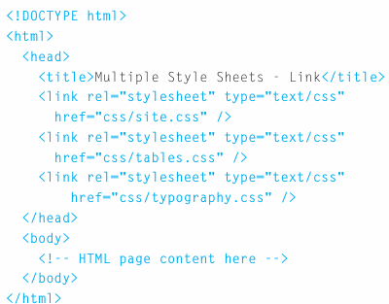

-Summary

+<div> elements are often used as containing elements to group together sections of page

+Browsers display pages in normal flow unless you specify relative, absolute, fixed positioning

+float moves content to left or right of page and used to create multi-column layouts. (floated items require a defined width)

+Pages can be fixed or liquid (stretchy) layouts

+Designers keep pages within 960-1000 pixels wide, and indicate what the site is about within the top 600 pixels (to demonstrate its relevance without scrolling)

+Grids help create professional and flexible designs

+CSS Frameworks provide rules for common tasks

+You can include multiple CSS files in one page

# Chapter 16: Images

-Controlling sizes of images in CSS

+width, height: control the size of image

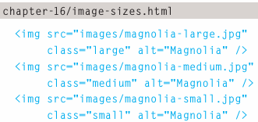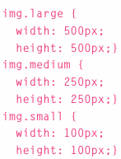

-Aligning images using CSS: float aligns images. There are 2 ways:

+float added to class that was created to represent the size of image

+New classes are created with name such as align-left or align-right to align the images to left or right.

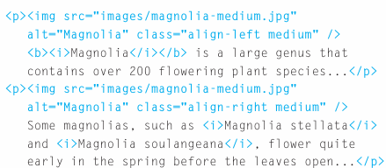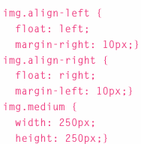

-Centering images using CSS

+By default, images are inline elements. To center image, it should be turned into block-element using display:block. Then use text-align:center or margin left+right:auto

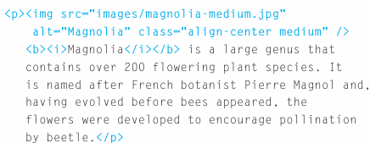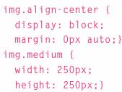

-Background images: background-image

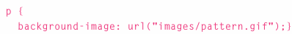

-Repeating images: background-repeat, background-attachment

+background-repeat: repeat (both horizontally and vertically), repeat-x, repeat-y, no-repeat

+background-attachment: whether a background image should stay in one position or move as user scrolls up and down the page: fixed, scroll

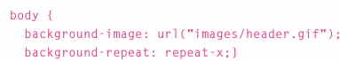

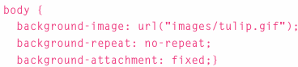

-Background position: background-position: when image is not being repeated, you can use it to specify where in the browser window the background image should be placed

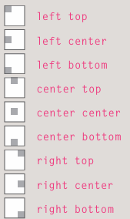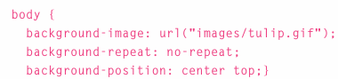

+You can use a pair of pixels/percentages. These represent the distance from the top left corner of browser window

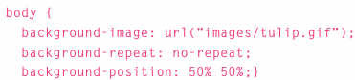

-Shorthand: background 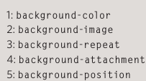

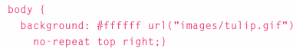

-Image rollovers & sprites

+In CSS, it’s possible to create a link or button that changes to a 2nd style when user moves mouse over it (rollover) and 3rd style when clicking on it. This is achieved by setting a background image for link or button that has 3 different styles of same button

+When a single image is used to several different parts of an interface->sprite. You can add logo and other interface elements, and buttons to image

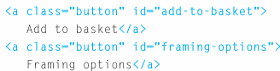

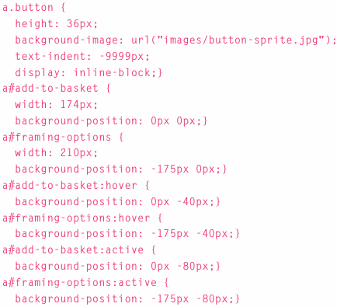

-CSS3: gradients: background-image

+The gradient use background-image and different browsers required a different syntax.

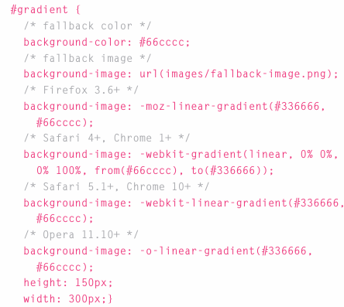

-Contrast of background images:

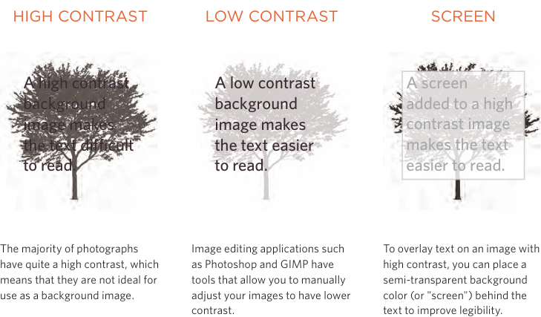

-Summary:

+You can specify the dimensions of image using CSS. This is very helpful when you use the same sized images on several pages of your site.

+Images can be aligned both horizontally and vertically using CSS.

+You can use background-image behind the box created by any element

+Background images can appear just once or be repeated across the background of box

+You can create image rollover effects by moving the background position of an image.

+To reduce the number of images your browser has to load, you can create images sprites.

# Chapter 17: HTML5 Layout

-Traditional HTML layouts

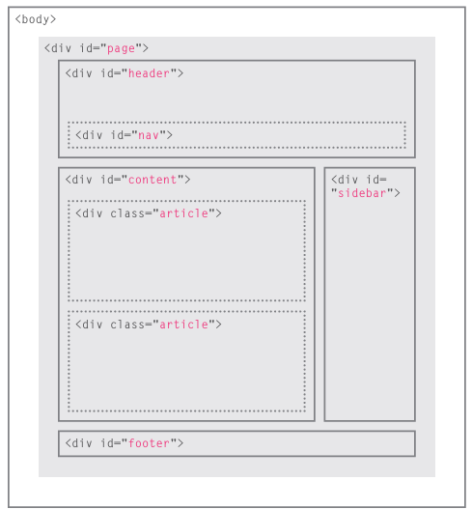

-New HTML5 layout elements:

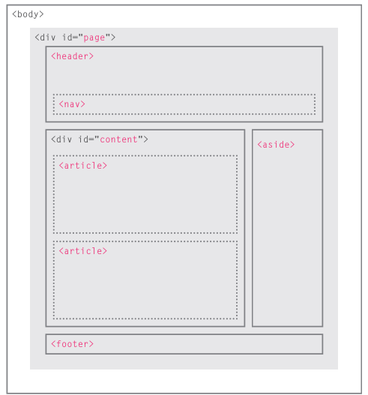

-Headers & footers: <header> <footer>

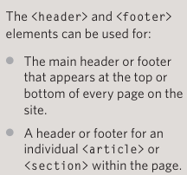

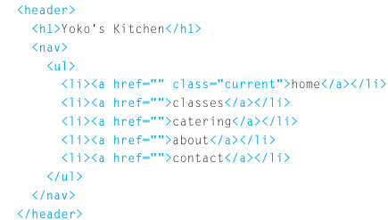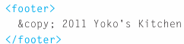

-Navigation <nav>: contain the major navigational blocks on site such as primary site navigation

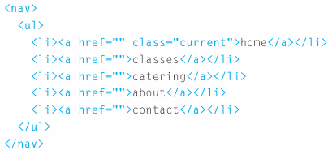

-Articles <article>: a container for any section of page that could stand alone and potentially be syndicated. This could be an individual article or blog entry, a comment or forum post, or any other independent piece of content.

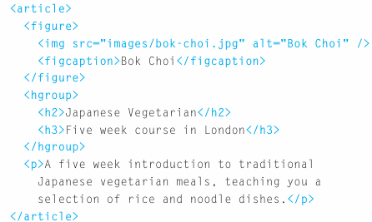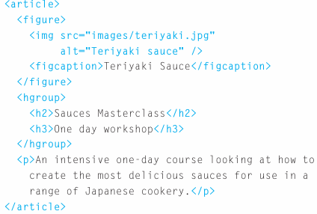

-Asides <aside>:

+When <aside> is inside <article>, it should contain information that is related to article but not essential to its overall meaning.

+When <aside> is outside <article>, it acts as a container for content that is related to entire page.

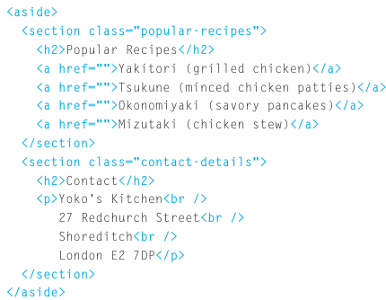

-Section <section>: group related content together, and each section would have its own heading. It may contain several distinct <article>.

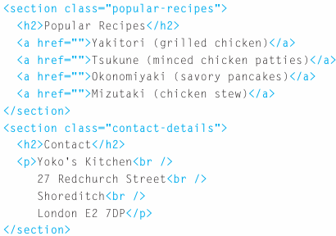

-Heading groups <hgroup>: group together a set of one or more <h1> through <h6> so that they are treated as one single heading.

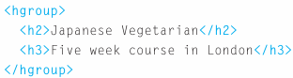

-Figures <figure> <figcaption>

+<figure> contain any content that is referenced from the main flow of an article: images, videos, graphs, diagrams, code samples, text that supports the main body of an article.

+<figure> should also contain a <figcation> providing a text decription for the content of <figure>

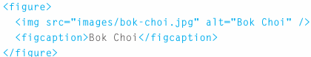

-Sectioning elements <div>: group together related elements. Where there is not suitable element to group a set of elements, <div> still be used.

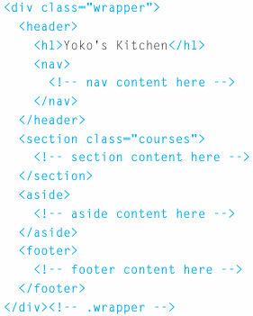

-Linking around block-level elements: HTML5 allows authors to place an <a> around a block level element that contains child element. This allows to turn an entire block into a link

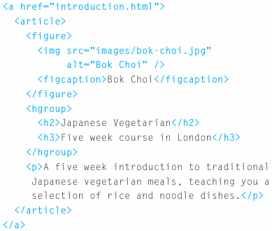

-Helping older browsers understand

+Older browsers that don’t know new HTML5 elements will treat them as inline elements. You should include CSS line on left which states which new elements should be referenced as block element

+To style elements using earlier versions of IE, use JS known as HTML5 shiv or HTML5 shim. Don’t need to understand JS to use it. Just link to a copy that Google hosts on its servers. It should be placed inside conditional comment which checks if the browser version is less than IE9.

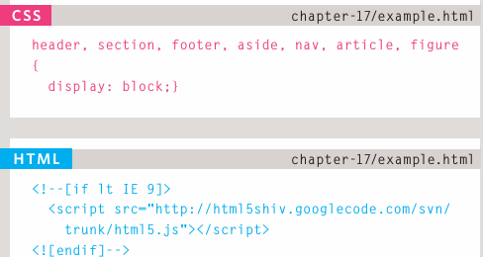

-Summary

+The new HTML5 elements indicate the purpose of different parts of a web page and help to describe its structure

+The new elements provide clearer code (compared with using multiple <div> elements)

+Older browsers that don’t understand HTML5 elements need to be told which elements are block-level elements.

+To make HTML5 elements work in IE8 (and older versions of IE), extra JS is needed, which is available free from Google.

# Chapter 18: Process & Design

-Who is the site for?

+Every website should be designed for the target audience-not just yourself or the site owner. It’s therefore very important to understand who your target audience is.

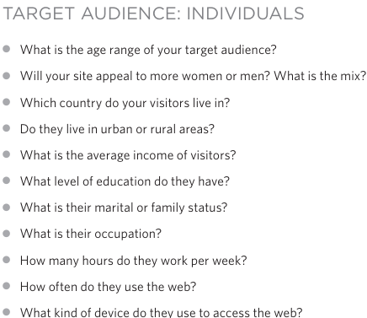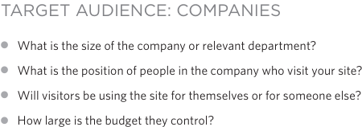

+Invent some fictional visitors from your typical target audience. They can influence design decisions from color palettes to level of detail in description

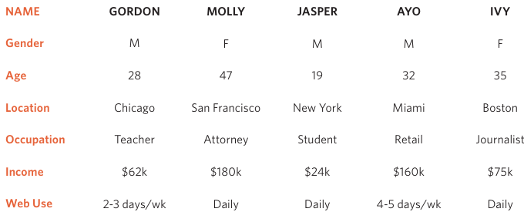

-Why people visit your website

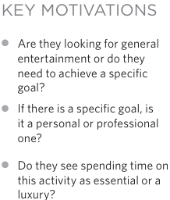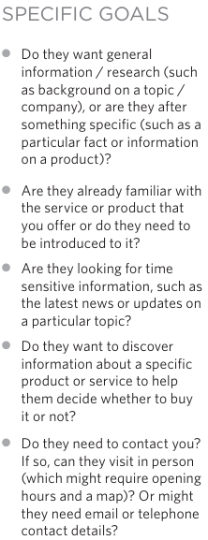

-What your visitors are trying to achieve

+It’s likely that you will be able to list every reason why someone visits your site but you are looking for key tasks and motivations. This information can help guide your site designs.

+1st you want to create a list of reasons why people would be coming to your site. You can then assign the list of tasks to the fictional visitors.

-What information your visitors need

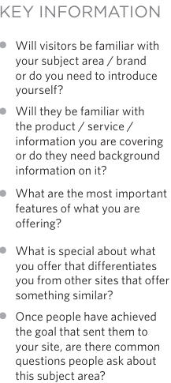

-How often people will visit your site:

+Some sites benefit from being updated more frequently than others. Some information (such as news) may be constantly changing, while other content remains static.

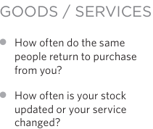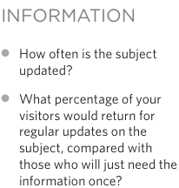

-Site maps: show how those pages can be grouped. You can use a technique card sorting: place each piece of information that a visitor might need to know on a separate piece of paper and then organizing the related information into groups.

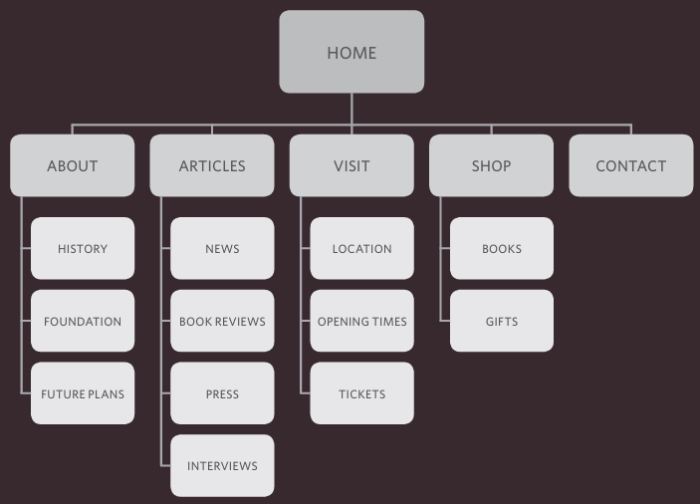

-Wireframes: a simple sketch of the key information that needs to go on each page of a site. It shows the hierarchy of information and how much space it might require. You should not include the color scheme, font choices, backgrounds or images for website in wireframe. It should focus on what information needs to be on each page and create a visual hierarchy to indicate the most important parts of each page.

+You can sketch wireframes on paper or use a graphics app on computer (Illustrator or InDesign)

+Online wireframe tools: 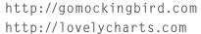

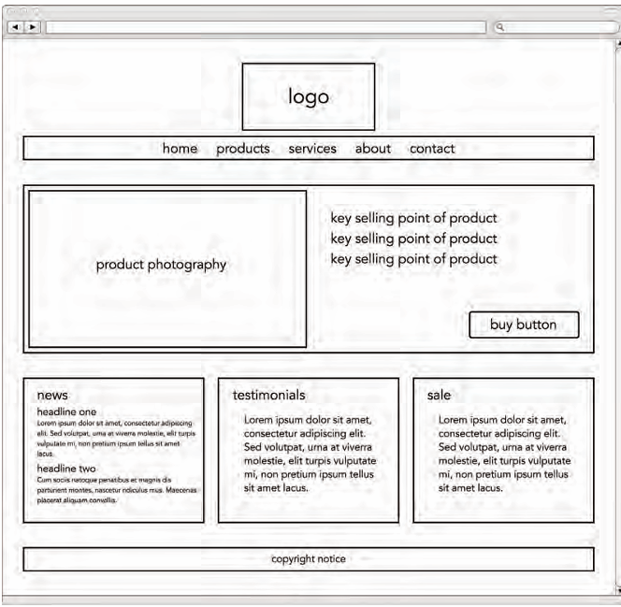

-Getting your message across using design

+The primary aim of visual design is to communicate. Organizing and prioritizing information on page helps users understand its importance and what order to read it in.

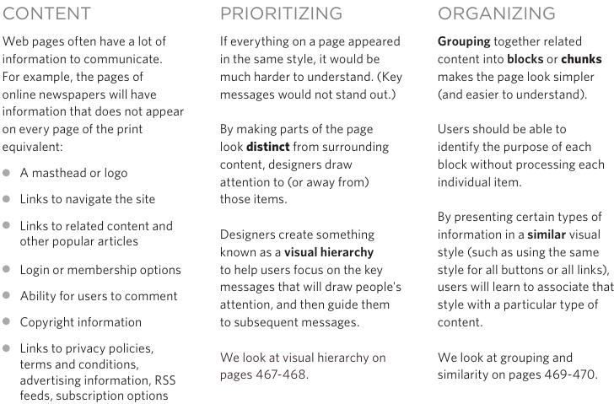

-Visual hierarchy: Across the key message and help users find what they are looking for.

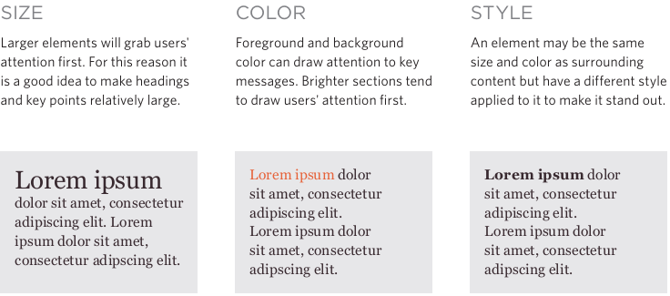

+Visual hierarchy created by adding visual contrast between items being displayed. Images create a high visual contrast and often attract the eye first.

-Grouping and similarity

+We tend to organize visual elements into groups. Grouping related pieces of information together can make design easier to comprehend

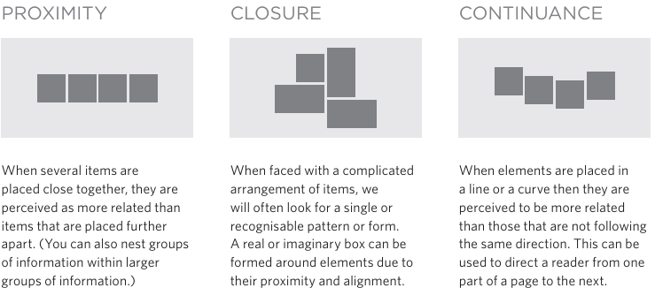

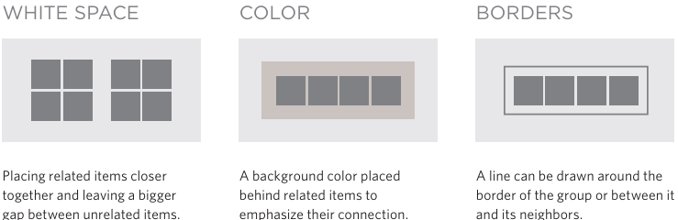

+Repetition of similar color, size, orientation, texture, font, or shape, suggests that matching elements have similar importance or meaning: consistency, headings

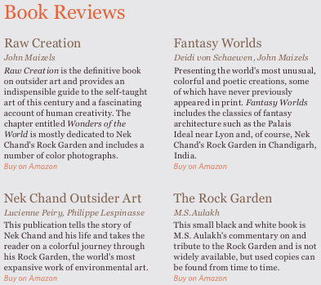

-Designing navigation

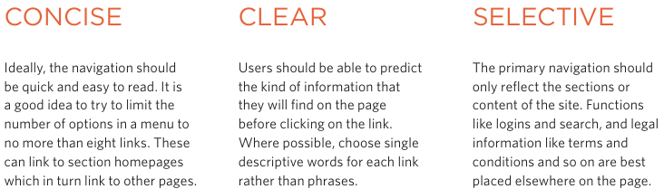

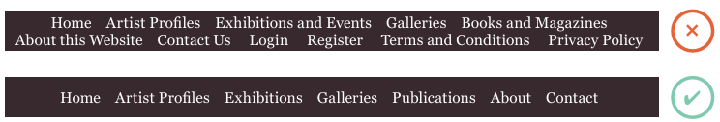

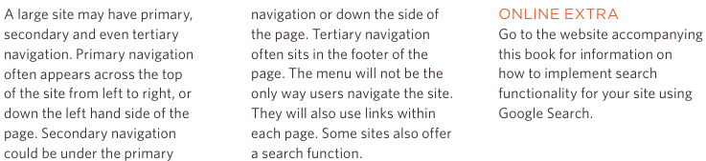

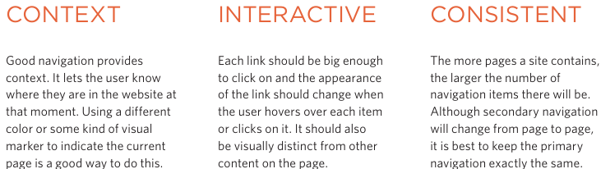

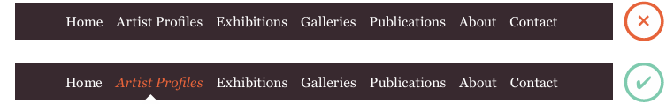

-Summary

+It's important to understand who your target audience is, why they would come to your site, what information they want to find and when they are likely to return.

+Site maps allow you to plan the structure of a site.

+Wireframes allow you to organize the information that will need to go on each page.

+Design is about communication. Visual hierarchy helps visitors understand what you are trying to tell them.

+You can differentiate between pieces of information using size, color, and style.

+You can use grouping and similarity to help simplify the information you present

# Chapter 19: Practical Information